The Anti-Anxiety Diet

Although anxiety stems from a variety of factors, one thing is certain: Diet plays a very important role. As holistic beings, our mental and physical health are inseparable. How we nourish our bodies, therefore, determines how well we achieve a calmer state of mind.
Studies have shown that gut health, particularly, the gut microbiome, affects anxiety and other mental conditions. Among its roles, optimized gut health improves anxiety and depression by reducing inflammation and boosting hormones like serotonin. About 95 percent of this feel-good neurotransmitter, in fact, gets manufactured by your gut. Newer studies (https://www.ncbi.nlm.nih.gov/pmc/articles/PMC5045149/) show your microbiome can also influence other emotions like anxiety.

11 Anti-Anxiety Diet Tips For Everyday Life
- Avoid Sugar. This is one that seems hard to ignore simply due to the fact that sugar hides in everything! Studies have shown that although sugar does not cause anxiety, it does create changes in your body which can exacerbate anxiety symptoms and impairs the body’s ability to effectively cope with stress.
A sugar crash is very similar to that of a caffeine crash, and can also cause mood changes, heart palpitations, difficulty concentrating and fatigue – all of which can be interpreted as the beginning stages of anxiety or panic attack.
- Don’t Skip Meals. Skipping meals crashes blood sugar, leaving you feeling lethargic and anxious. Time is of the essence, but if you are skipping breakfast or other meals, then you are asking for trouble on the anxiety front. Skipping meals during the day can cause your blood sugar levels to plunge, bringing on anxiety and irritability.
Another problem is consuming too many carbs and too little protein at breakfast time. You normally need about 25 grams of protein at breakfast to prevent those blood sugar levels from going crazy. Just add in an egg, protein powder, or some nuts to prevent another awful day.

- Avoid Dairy. Research shows that people who have anxiety say that they’ve noticed an increase in anxiety symptoms within minutes of consuming dairy products. Approximately 10% of adults are lactose intolerant, with even more having difficulty digesting casein, found in cow’s milk.

Dairy is inflammatory and wreaks havoc on the digestive system causing bloating, diarrhea and constipation among other things.

- Eliminate Caffeine. Caffeine is a known stimulant and psychoactive drug and has long had a reputation for triggering the body’s fight or flight response. Very similar to these symptoms associates with anxiety, caffeine can also make you feel nervous, nauseous, light headed, jittery and anxious. If you’re suffering though anxiety, I recommend you consider herbal tea or a green drink instead.

- Eat healthy fats. With such an emphasis on “fat-free” and “low-fat” in Western food culture, many people fail to realize that fat plays an important role in our bodies. It assists in the absorption of fat soluble vitamins A, D, E, and K. Fatty acids also play a significant role in brain health. The trick is in obtaining the right types of fats for good mental health. These include fats in raw nuts and seeds, avocados, and coconut oil. Eat plenty of these foods to protect your overall brain health, particularly those containing Omega-3 fats like chia and flaxseeds.

- Drink plenty of water. Some studies show that water is a great “anxiety quencher”. When the body is dehydrated, in can actually induce anxiety and nervousness. When we are dehydrated our cells feel it at the molecular level and communicate this to the subconscious as an underline subtle anxiety or threat to survival. The key to rebalance this deficit of fluids is to drink eight glasses of fresh water a day. Water alone may not cure anxiety but it sure can help calm those nerves!

- Go Gluten-Free. Gluten is a protein found in wheat, barley and rye products. For many anxiety sufferers, gluten can also be a huge trigger for anxiety symptoms. Research has now confirmed that people with Celiac disease and gluten intolerances (like myself) are at a higher risk for anxiety, depression and mood disorders. You can talk to your doctor about getting tested but in the meantime, if you’re suffering from anxiety, it’s best to avoid or limit consumption of gluten. Cutting out gluten could be the difference between living with anxiety and minimizing/managing it for the better.

- Avoid alcohol. Alcohol in excess or at all (for some), is said to induce symptoms of anxiety. Alcohol is a toxin that leads to improper mental and physical functioning, by negatively impacting the levels of serotonin (the feel good chemical), in the brain.

Alcohol also affects the body and nervous system and can cause hypersensitivity, increased heart rate, lowered blood sugar levels and acute dehydration

- Supplement when necessary. Even when we eat healthy, if anxiety has been in your life for a while, it may take some additional support with some all-natural nutritional supplements, herbal remedies, or botanicals. If you’re interested in finding out if you could benefit, feel free to book a Nutritional Assessment + Testing to find out which one’s would be best for your body.

- Avoid processed foods. Generally, processed foods are high in sugar and/or gluten and a bunch of additional additives and preservatives. Refined flours and sugars are said to feed the harmful bacteria and microbes in the gut. With more research being conducted, the general consensus is that gut health is a major contributor to chronic anxiety, and many mood disorders can be treated by proliferating good bacteria in your gut.

- Get vitamin D. According to the Vitamin D Council, low serum levels of vitamin D can lead to anxiety or depression. Many people can get the vitamin D they need from the sun; however, in some northern locations or in the winter, vitamin D levels may wane. Consider supplementing vitamin D for optimal mental health, and try to spend at least 10-20 minutes in the sunlight without sunscreen each day.

Check out these great foods to help you keep calm and carry on

Most often we hear about the anxiety-promoting effects of too much caffeine, skipping a meal, or too many simple carbohydrates. But what we don’t often hear about are foods that actually reduce anxiety.

1. Beans: Not only are beans good for the heart, as the saying goes, but they are also good for the nerves. Beans offer a healthy dose of fiber, which slows the digestion process and results in more stable blood sugars. Physiologically, this prevents the body from going on an undesirable roller-coaster ride—one that goes from buzzing to crashing. Beans are also an excellent source of antioxidants. In fact, they’re right up there with popular superfoods such as berries. So what does this have to do with anxiety? Turns out an antioxidant-rich diet has been found to protect the body from harmful free radicals (which anxiety promotes).

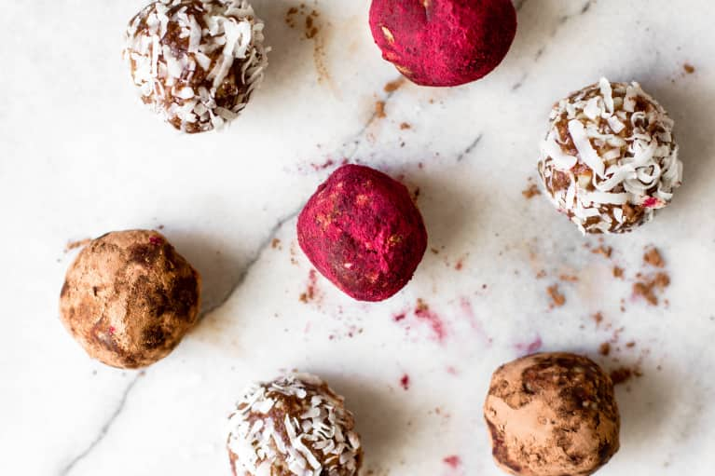
2. Cashews: Cashews are a wonderfully versatile nut. They can be made into vegan ricotta, savory or sweet cream sauces, or even energy bites. They're also a good source of zinc, which is a trace mineral essential for brain function. Zinc is like a behind-the-scenes agent when it comes to anxiety. It’s role is to convert vitamin B-6 to its active form, which goes on to help synthesize serotonin, a neurotransmitter known for maintaining mood balance. Getting enough zinc in the diet, therefore, is essential for mood balance.

3. Yogurt: Yogurt is a probiotic-rich food. The consumption of probiotics has been shown to significantly reduce symptoms of anxiety, according to a recent study. Although the exact reason is unknown, consuming probiotic-rich foods can be a great low-risk strategy to reduce anxiety. Other probiotic-rich foods to include in your regular diet are kombucha, kefir, kimchi, pickles, sour cream, sauerkraut, and tempeh. *Yogurt is not advised if you are on a detox program or healing your gut from candida and other bacteria.

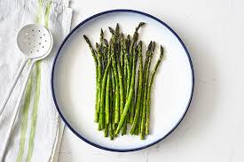
4. Asparagus: Asparagus extract is used in traditional Chinese medicine (TCM) as a tonic, cough suppressant, and diuretic agent. More recently, though, the extract has been used in mice to study its effect on anxiety reduction. One study found that asparagus extract was very effective in reducing anxiety symptoms. Although it may be difficult to find asparagus extract, eating asparagus when it’s in season is a beneficial (and delicious!) alternative.

5. Lemon: Looking to start a new health routine that can also help ease anxiety? Lemon water is your answer! Abundant in vitamin C, this lovely citrus fruit is known for its powerful antioxidant abilities. In regard to anxiety, vitamin C is quickly used up when the body is under stress. And if there is not enough vitamin C available, this can actually extend the stress response lead to higher cortisol levels in the body over a longer period of time—so to keep chronic stress away, plenty of vitamin C is required.

6. Salmon: Salmon is an excellent source of omega-3 fatty acids, an essential fat we must get from our diet. Omega-3s play an important role in brain development and function. Just like zinc, omega-3s are highly concentrated in the brain. Authors in one randomized-controlled study evaluated the effects of omega-3 fatty-acid supplementation on anxiety reduction and found that subjects reduced their anxiety symptoms by 20 percent and also had lower levels of inflammation. To keep those nerves in check, eat at least two servings per week of fatty fish like salmon.

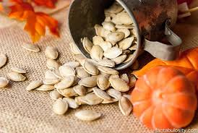
7. Pumpkin seeds: Delivering almost 40 percent of the daily value of magnesium in just 1 ounce (~¼ cup), pumpkin seeds are another surprising food that reduces anxiety. Most adults are deficient in magnesium, and magnesium is crucial in regulating our internal response to stress. When magnesium is deficient in our diets, our bodies are less capable of reducing the amount of stress hormones released. Next time you’re at the salad bar or preparing oatmeal or making muffins, be sure to add magnesium-rich pumpkin seeds to help fight off stress.

8. Oats: Oats are abundant in many vitamins and minerals helpful in reducing anxiety. They contain B-vitamins, magnesium, and fiber, all of which help control stress. Because oats are whole grains containing complex carbohydrates, eating them is a great way to increase serotonin production. And serotonin, as we know, is a major antidepressant and anti-anxiety hormone. Starting the day with oatmeal for breakfast just might be the difference between a stress-reduced or stress-filled day. *Make sure they are gluten free.

9. Dark chocolate: Easily one of the most exciting ways to manage stress, dark chocolate is an instant mood lifter with benefits to back up its use. Not only does dark chocolate contain antioxidants and magnesium, but it also contains an interesting fatty-acid neurotransmitter called anandamide. Anandamide has mood-lifting effects in the body and has recently been found to reverse stress-induced anxiety in mice. These results suggest that reaching for dark chocolate when we are stressed is not a bad thing and can actually be helpful in managing anxiety. *Avoid or go for low sugar dark chocolate if you are on the Opening Channels program or eliminating candida.

